

Ahmed Abdallah Youssef Mohamed Mosad

15p8114 16P8221

Industrial Robotics

Task 3

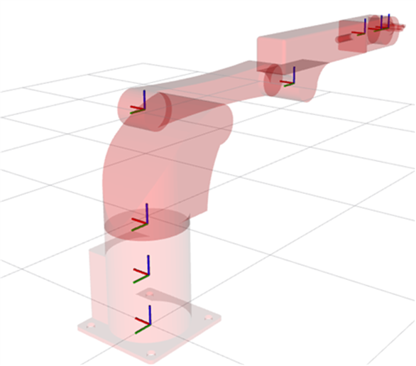

# Model Section

The model taken from Rviz workspace is as shown in the following figures.

# Motion Planning Section

Trajectory for each Joint is shown in the following figures

* A screenshot of a computer

  Description automatically generatedJoint 1
* Joint 2

* Joint 3

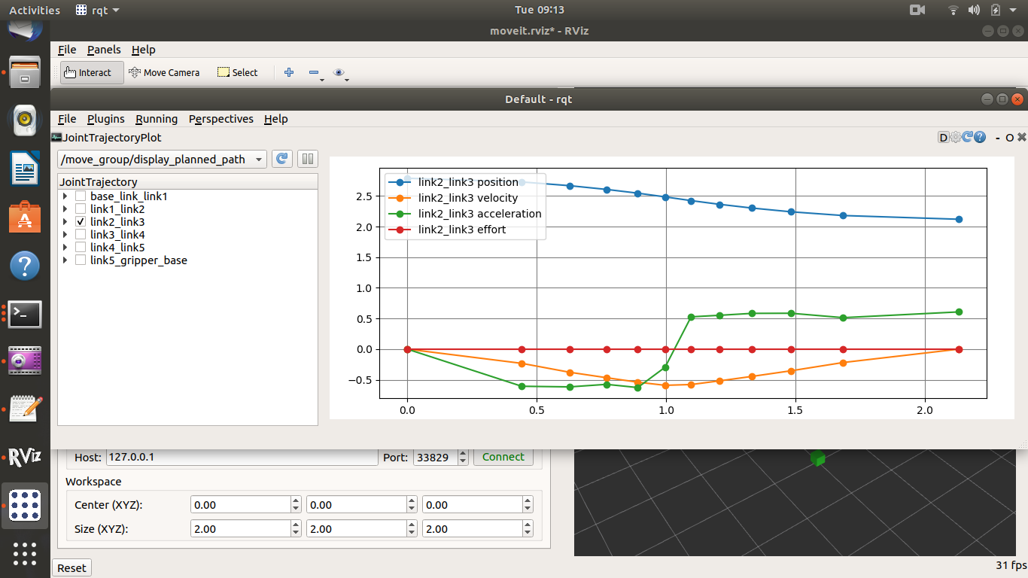

* A screenshot of a computer

  Description automatically generatedJoint 4
* A screenshot of a computer

  Description automatically generatedJoint 5
* Joint 6

